**EXP 5)** Create a simple cloud software application for Mark Sheet Processing System using any Cloud Service Provider to demonstrate SaaS include the necessary fields such as name of the student, Reg no of the student, Subjects , Marks, Average, percentage, rank, overall performance etc.

**PROCEDURE:**

**STEP1:** GOTO ZOHO.COM

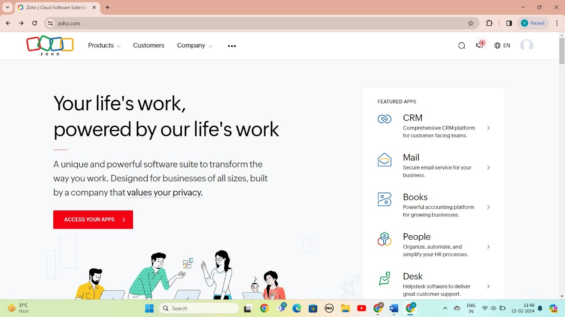

STEP 2: LOGIN TO THE ZOHO.COM

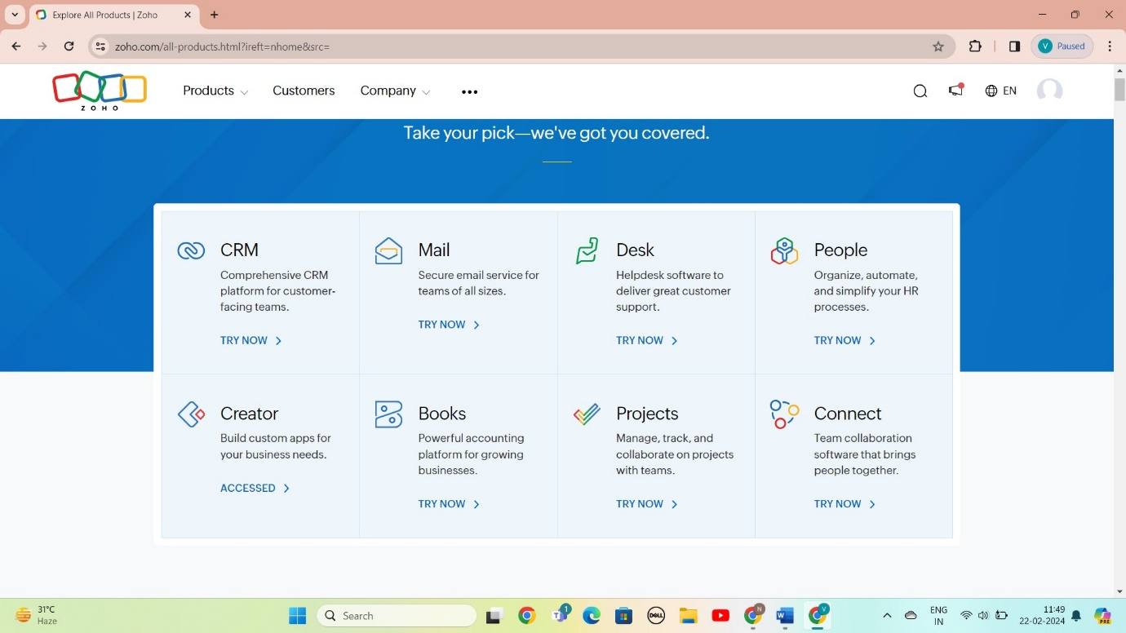

STEP 3: SELECT A CREATE FROM SCRATCH

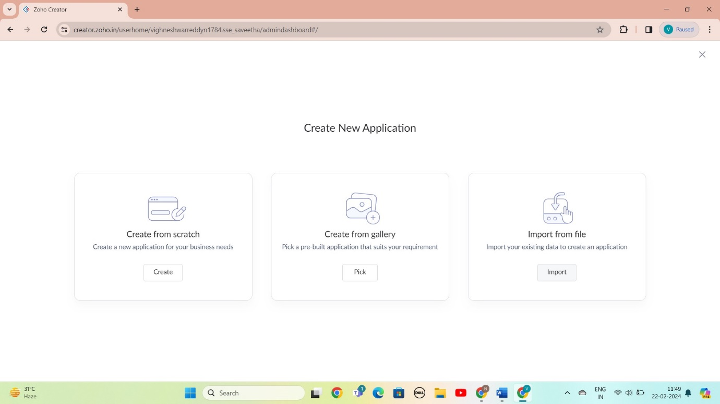

STEP 4: SELECT APPLICATION NAME AS Mark Sheet Processing System

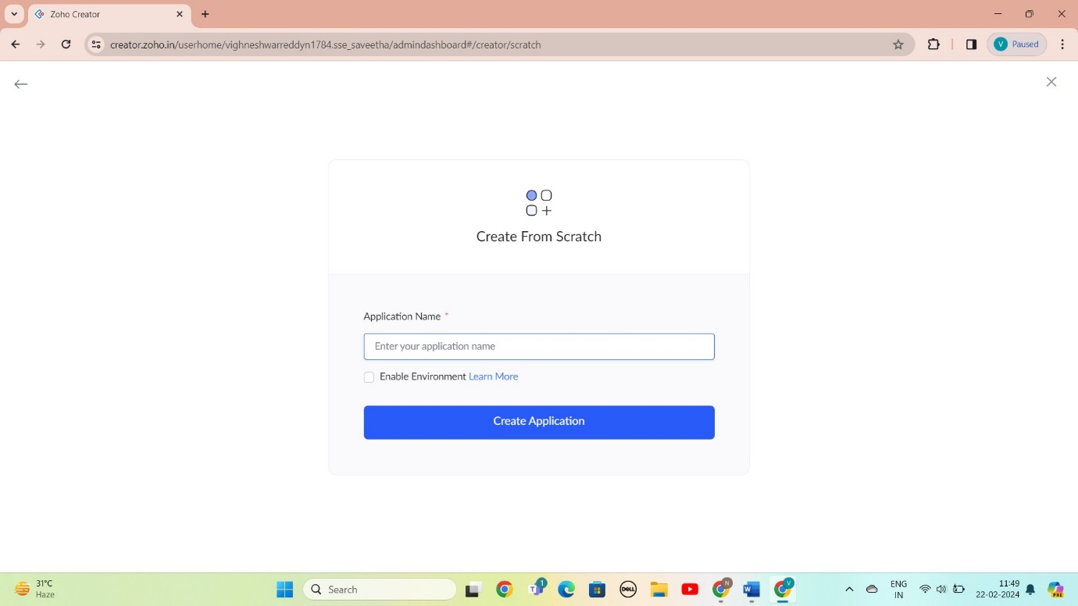

STEP 5: CREATED NEW FORM

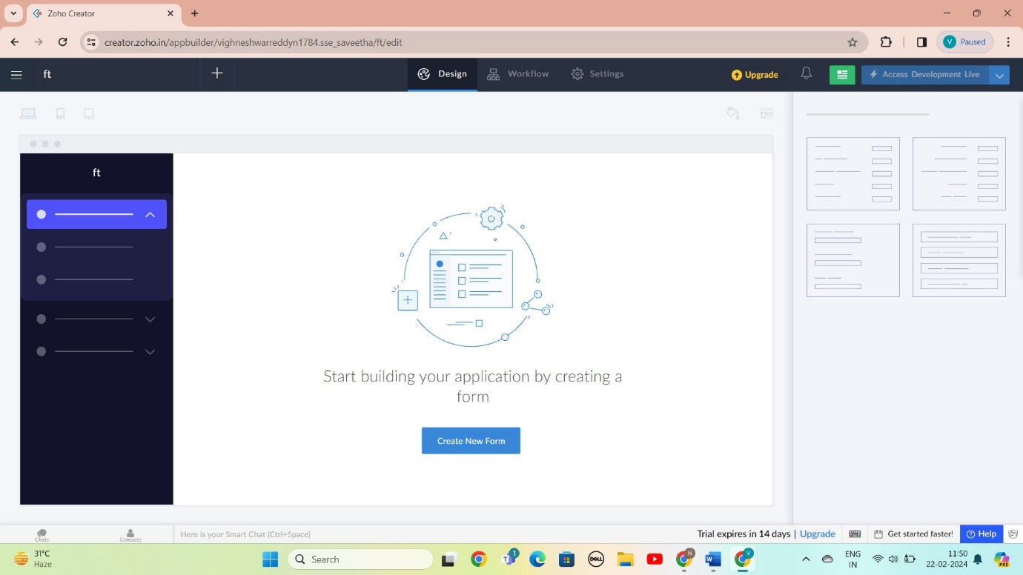

STEP 6: SELECT BASIC FILED FROM GIVEN BELOW AND DEVELOP APPLICATION

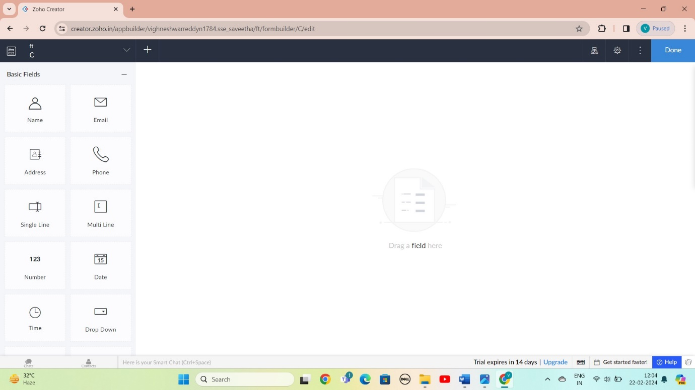

STEP 7: THE SOFTWARE AS BEEN CREATE LOGIN

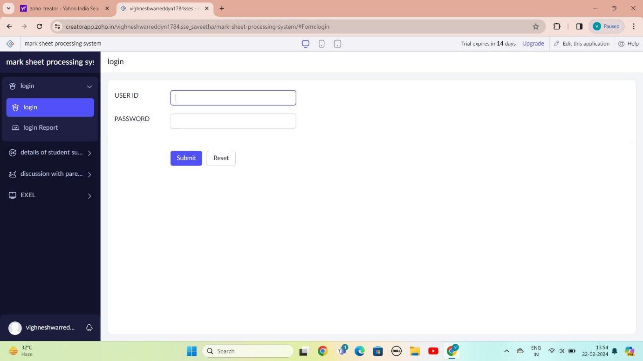

STEP 8: THE SOFTWARE AS BEEN CREATE EXEL

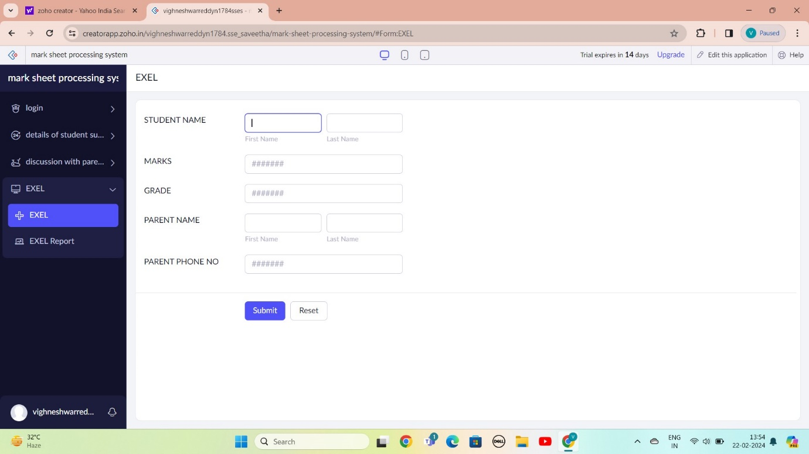

STEP 9: THE SOFTWARE AS BEEN CREATE DETAILS OF STUDENT

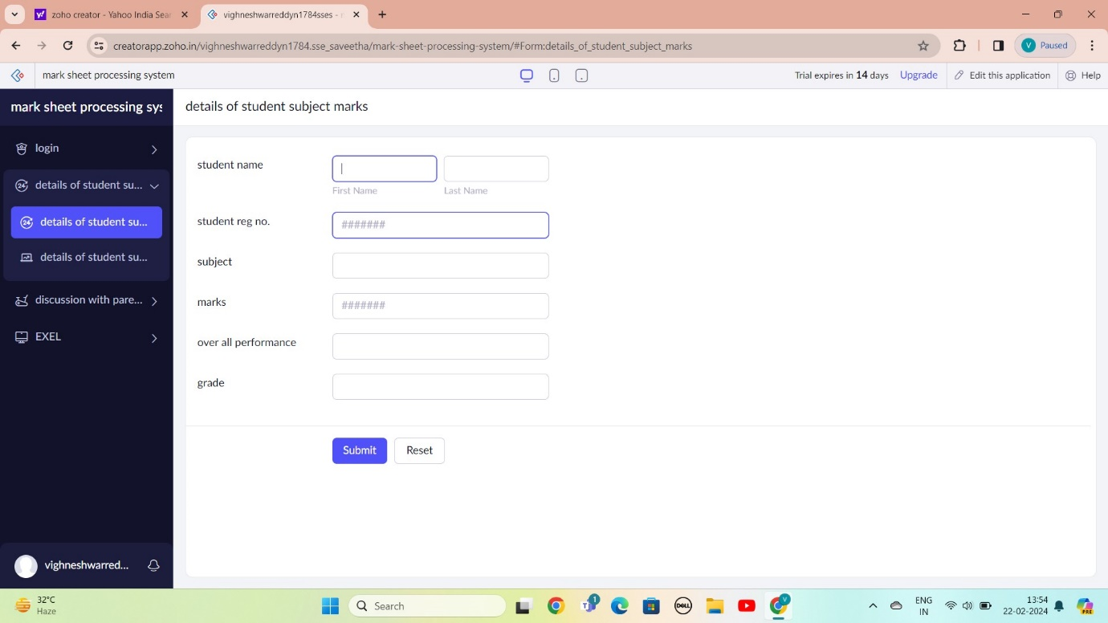

STEP 10: THE SOFTWARE AS BEEN CREATE DISCUSSION WITH PARENTS

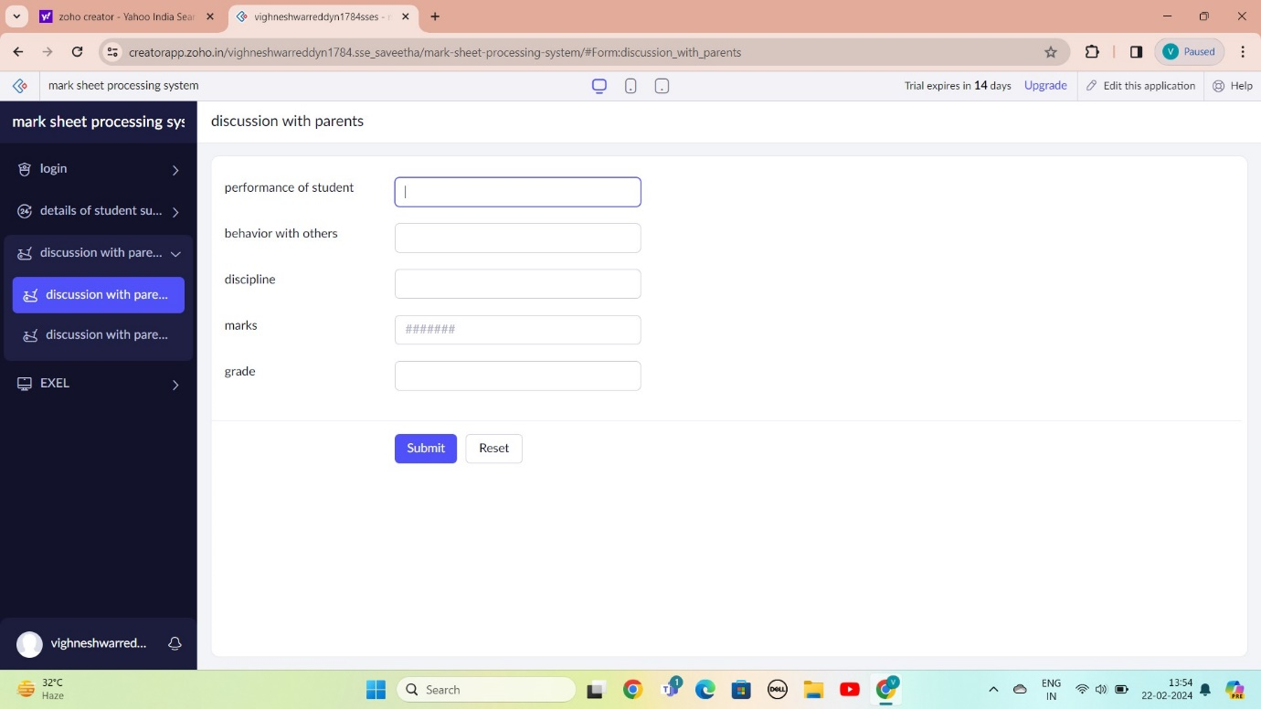

STEP 11: THE SOFTWARE AS BEEN CREATE

